Jamie Schroder: “Linden Creek, where’s that?” I’ve heard that often enough when I’ve mentioned it to other fishers. Linden Creek for those of you who aren’t familiar with it, is in North Strabane Township in the South Hills and is the primary stream that flows into Canonsburg Lake.
Depending upon who you talk to, or which map you may use, the creek will be identified as either Linden Creek or Little Chartier’s Creek and consists of approximately 2 miles of quiet, fishable water that doesn’t get much attention from anglers. It runs the majority of its length alongside Linden Creek Road accessible from US Route 19. An identifying landmark is the Lindenwood Golf Club where the creek can be seen meandering through the fairways.
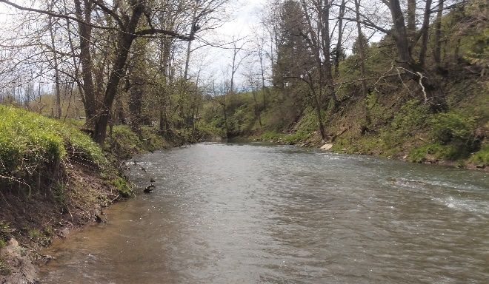

Linden Creek winds through neighborhoods and farmland and what I love about it are the stately Sycamore trees lining the banks and the grazing cattle that are visible as you wade along in this lovely creek. 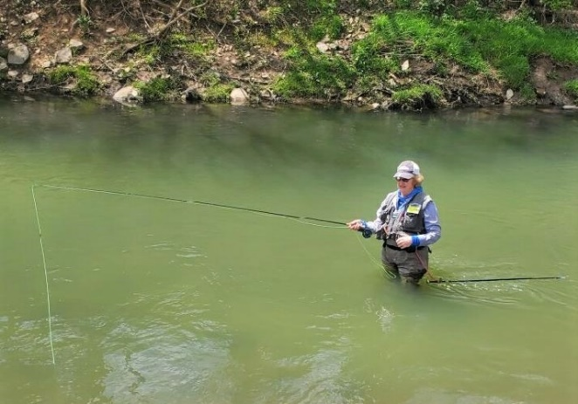
The creek is stocked with trout, and I should know, having participated last year when we stocked it in many spots; just about every bend and pool seemed to get at least one bucket of fish or more.
What surprised me in exploring Linden Creek for the first time in 2018 was a small portion of the creek that’s accessible from the Dormont Mt. Lebanon Sportsmen’s Club. People who want to fish in this area can pull into the private driveway to the Sportsmen’s Club and once alongside the creek find a parking area on the left. If you were to continue on that private drive you would come to a Members Only bridge providing access to the shooting property. Be forewarned, although safe, if you are going to fish in that stretch of the creek it’s advisable to bring earplugs because if you’re there at the wrong time of day your casting is going to be punctuated with blasts from the sportsmen’s guns. Even with the possibility of occasional noise it feels good to be in the water and be able to catch a trout or two in some of the pools.
My favorite place to fish is just beyond the golf course heading south and at the start of some farmland on the right hand side of the road. You can park your car on the left side of the road and walk across a field to get to the creek. For the most part the water is relatively shallow but there are a few deeper pockets where the fish like to hide. Actually, as beautiful as the area is, I will sometimes cast and ignore my line while watching Orioles and Pileated Woodpeckers overhead.

When I was there a few weeks ago I happened to notice a yellow flower growing up high in the crotch of a tree. I never did figure out what the flower was, I guess it could have been a dandelion but how clever of nature to allow a seed to take hold so far above ground. It was here that I caught my first fish of the season, a nice rainbow trout.
More than once while fishing I’ve been startled when a cow has bellowed only to find it next to me in the field on the high bank.
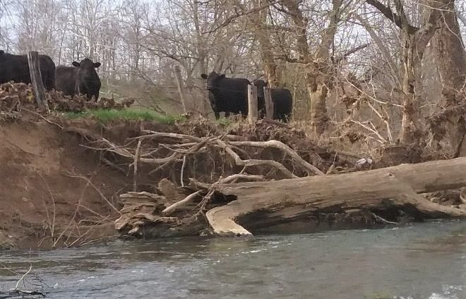
Last year I walked up the creek for about an hour and a half casting as I went but I didn’t really think so much about the fishing because I just loved the serenity and the scenery. From the apple trees along the banks, the shallow riffles, the freshwater clam shells and the turns that were so sharp I couldn’t see the creek beyond the bend, it was a perfect day to be on the water. I could have gone further but the light was fading and I had a good ways to get back through the woods to the road and my car.
Linden Creek is my local ‘somewhere special’ place to go when I’m looking for a quiet time on the water and the potential of catching another one of those elusive trout I know are in the stream. Come have a look at Linden Creek, a nice place to cast and enjoy nature and with a little luck you may even catch a fish.
