2020 PWWTU BOARD
Ed Barger
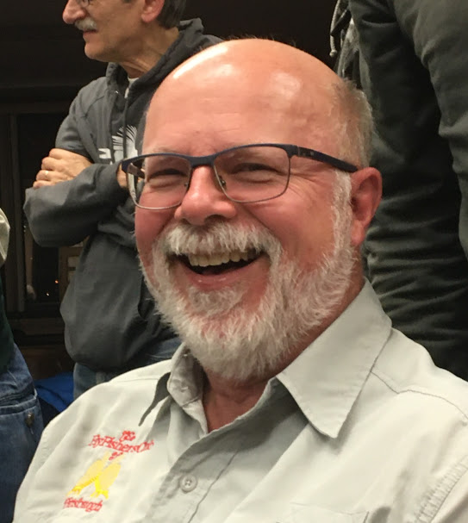
I have been fishing since the age of 3 or 4, and trout fishing since the age of 6, when my father took me to a local small stocked stream in Mercer County PA. I have been an avid fisherman ever since. Growing up in an area with large numbers of coal mines mines and acid mine pollution has made me appreciate the work that Trout Unlimited does to conserve existing and recover denigrated cold water resources across the country, along with other activities such as mentoring young fishermen and women in assisting with youth fishing days, providing educational opportunities such as our chapter's sponsoring intro to fly fishing and fly tying classes as well as our "Trout in the Classroom program, to name a few of the activities that chapter members participate in. I rejoined TU several years ago and started to attend PWW meetings on a regular basis. I recently retired and feel that I now have the time to devote to becoming more active in the chapter in a leadership position.
Ian Brown

I grew up in Calgary, Alberta, and cut my fly fishing teeth on the Bow River, which is a river that is unusual because it flows through a major metropolitan area. As such, I am familiar with the impact that a city can have on a stream, both good and bad, and I see the potential that this region has in its rivers and warm water streams. I’ll celebrate when the term “combined sewage overflow” becomes obsolete.
My focus in this area is more on warm water streams mainly because I can be on a smallmouth stream much more quickly than a trout stream. I've served on the board as Secretary now for a couple of years and am interested in continuing to contribute.

Chuck Buffington

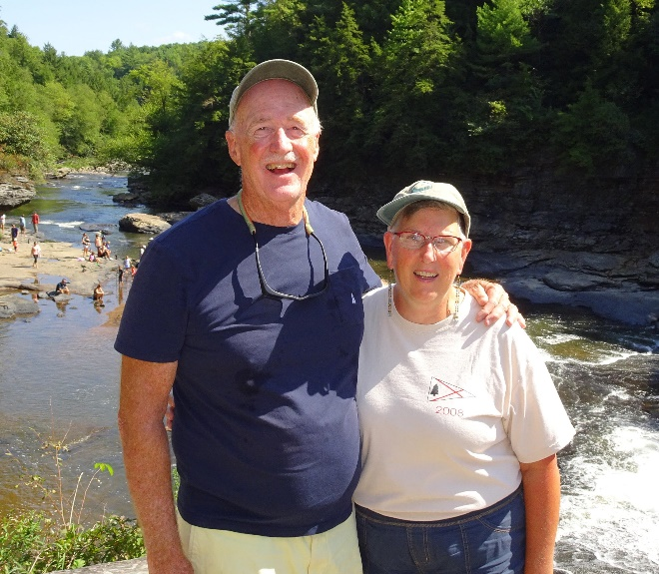

I am fully retired and have time and resources to devote to a leadership role in PWWTU. I have good quantitative and writing skills and an analytic approach to problems as a result of a career primarily focused on medical research.
I’ve served as Chair of the Membership Committee of PWWTU since 2013 and would like to become a Board member. I was informally elected President at the December, 2019 Chapter meeting and would like to continue in this role if elected to the Board.
I have prior administrative experience as the Director of the Anesthesia Residency at Univ. Pittsburgh (1994-1998), Executive Committee member and President (2009-2011), Flying Scot Sailing Association (2002-2016), and President, Four Hooppole South Condominium, Oakland, MD (2006-2012)
My vision is to involve the entire membership of PWWTU in conservation efforts in Allegheny County. We’re a large chapter with the ability to organize new conservation efforts and to provide money and manpower to new as well as ongoing projects such as Pine Creek.

Bob Bukk

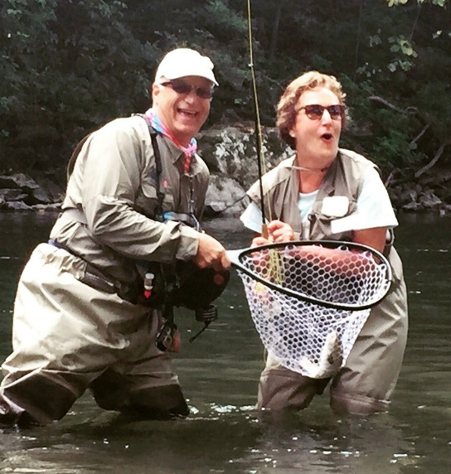

I have been a member of PWWTU for 40 years. I’ve served on the Board before and now that I’m retired, I look forward to providing time, energy and perspective to the group. My last position was Vice President.
One of my passions is helping breast cancer survivors recover through Casting for Recovery. I’m proud to be a “River Helper” and treasure the days spent on the water with these women.
I am a member of Pittsburgh Fly Fishers and was the recipient of their Fly Fisherman of the Year award which is given not only for fishing prowess but primarily for service to the organization..
During my working days, I found time to spearhead the $2M effort to build the SW PA WWII Memorial. I chaired the effort which involved working with artists, city administrators, labor, and state officials. Whew! It makes me sweat just thinking about it. But that experience taught me patience and the value of a level-headed approach to a wide variety of people and problems.
I think PWWTU should continue to work to make Pine Creek the great urban fishery that it is and to also pursue other conservation efforts, possibly partnering with other TU chapters in Western PA.
You can count on me to be a creative and active member of the Board if elected.
Nora Cline
I am a transplanted Pittsburgher who wants to share my enthusiasm and excitement for fishing and nature.

Bob Heil, Jr.

I’m a Pittsburgher, born and bred. I currently work in the lumber distribution industry but have ample free time to commit to a leadership position in PWWTU.
My work experience has taught me to solve problems by listening to everyone’s perspective, analyzing the issues, and seeking a solution that works for everyone involved.
I am a co-founder of Allegheny Fly Tiers and active teaching youth and adults the basics of tying a fly that fish will like. I currently volunteer with Project Healing Waters and am active in PWWTU, Pittsburgh Fly Fishers and Family Tyes.
I have the time and interest to participate fully in the PWW Board and whatever conservation and education projects the future holds.

Bryan Mathie
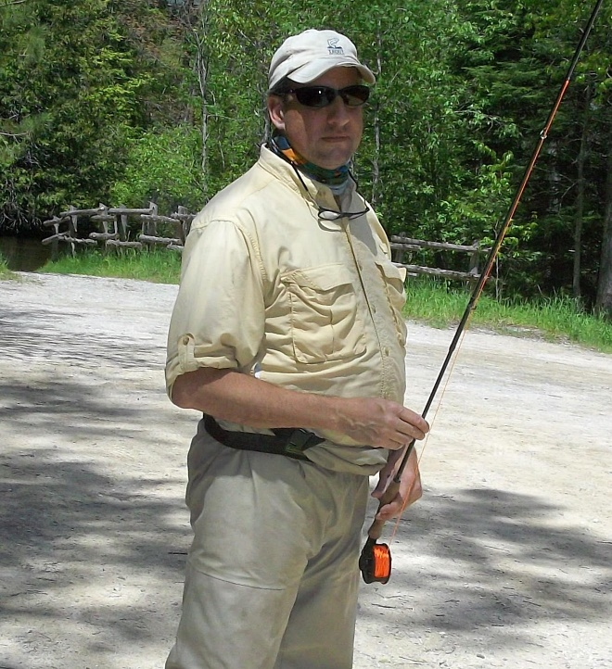

I spent my early years wading around in puddles collecting tadpoles. In later years growing up on the Great Lakes I watched the pollution kill fish but not invasive species of carp and zebra mussles. Protection of species and natural resources was a focus of my education (Biology BS) and remains an abiding interest.
I appreciate the importance of clean, cold, fresh water, and I have a passion to preserve it. I missed the opportunity to do TU conservation of the Driftless Area of Wisconsin when I lived in Chicago because of young children and work. Now, it seems the chance has come around again.
My idea is to assemble a group of PWWTU members with similar passion to 1. Connect with other chapters to understand current best conservation practices; 2, Evaluate potentially remedial problems in the streams of Allegheny County, including Pine Creek. 3. Partner with deep pockets in industry and government to fund specific stream projects.

Jamie Schroder

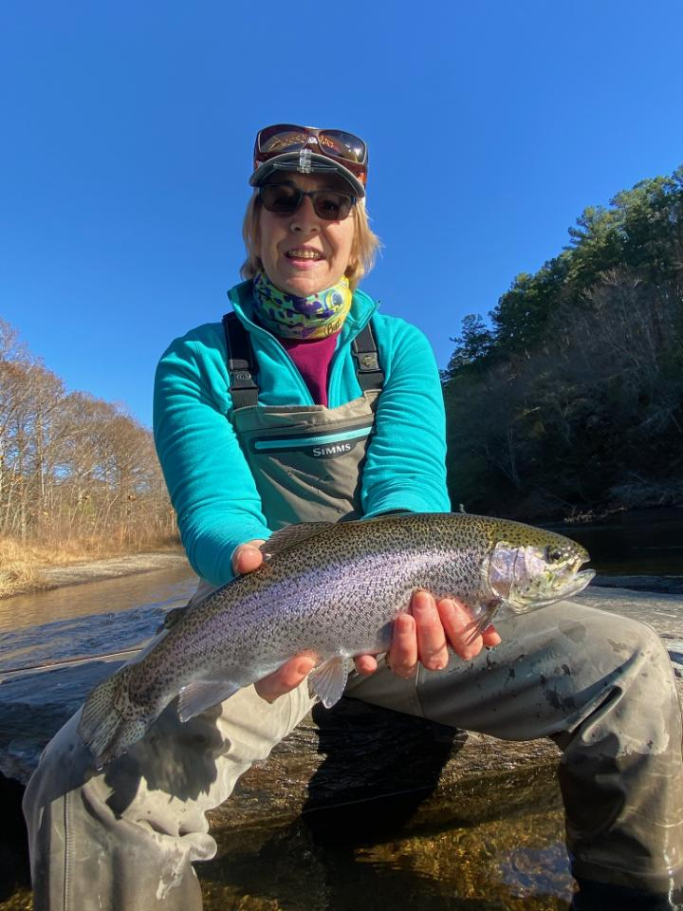

I'm thrilled to be a member of TU and especially the very active women's initiative.
I was raised to appreciate nature whether that was skiing, riding, or fishing with my father. Now as an adult it's been tremendous to discover fly fishing. I believe that along with enjoying the sport comes a responsibility to help maintain and conserve our freshwater streams and rivers and the land around them. I want to be a part of this and believe my lifetime spent appreciating nature combined with my keen interest in promoting this sport will help me add value to the group.

Christian Shane

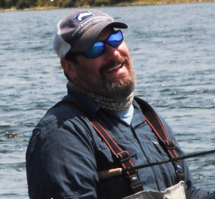

Christian Shane has been involved with Penn’s Woods West Trout Unlimited for over twenty years in capacities such as the Hatches & Rises Newsletter Editor, Trout in the Classroom Coordinator, Program and Meeting Coordinator, Board Member, Pine Creek Clean-up worker, Cabin Fever volunteer, and other chapter jobs.
He’s coordinated the Trout in the Classroom project in his North Allegheny classroom for over thirteen years, reaching many students and families to appreciate the trout life cycle and learn the importance of clean, cold water.
He’s an avid fly fisherman, fly tier, Middle School educator, and outdoor writer. His current angling pieces can be found in PA Angler & Boater Magazine with the “Tying Together” articles and his work has also been featured in The Drake Magazine, Montana Fly Fishing Magazine, PA Outdoor News, and Kype Magazine. His latest writing project, a Middle Grade adventure novel called Salmon Survivor, is currently underway.

